Table of Contents
1. Working With Github 2
1.1. Installing 2
1.2. Cloning the repository 2
1.3. Checking in updates 3
2. Qt Setup 4
3. Project Folder Structure 6
3.1. Source Code Structure 6
3.2. Graphics Directory structure 7

Working With Github

Installing
Install Github:
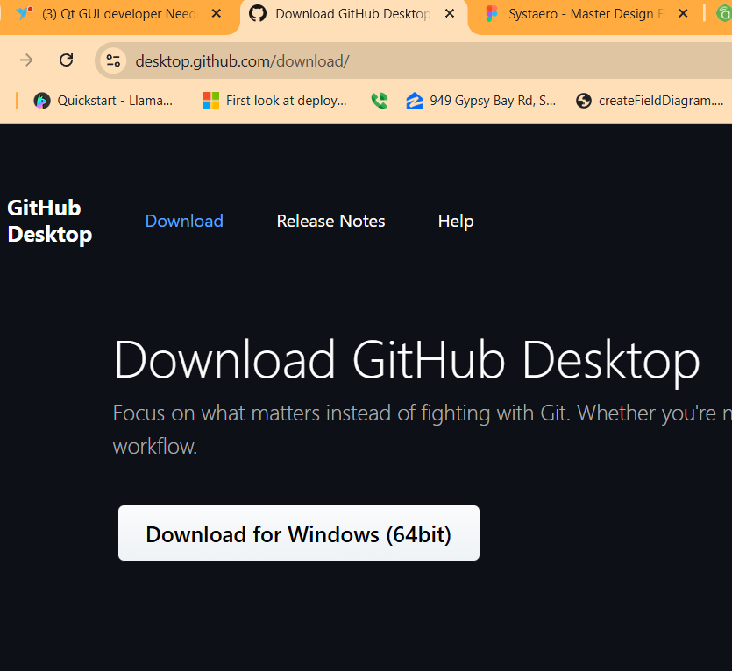

Cloning the repository
Clone the repository:
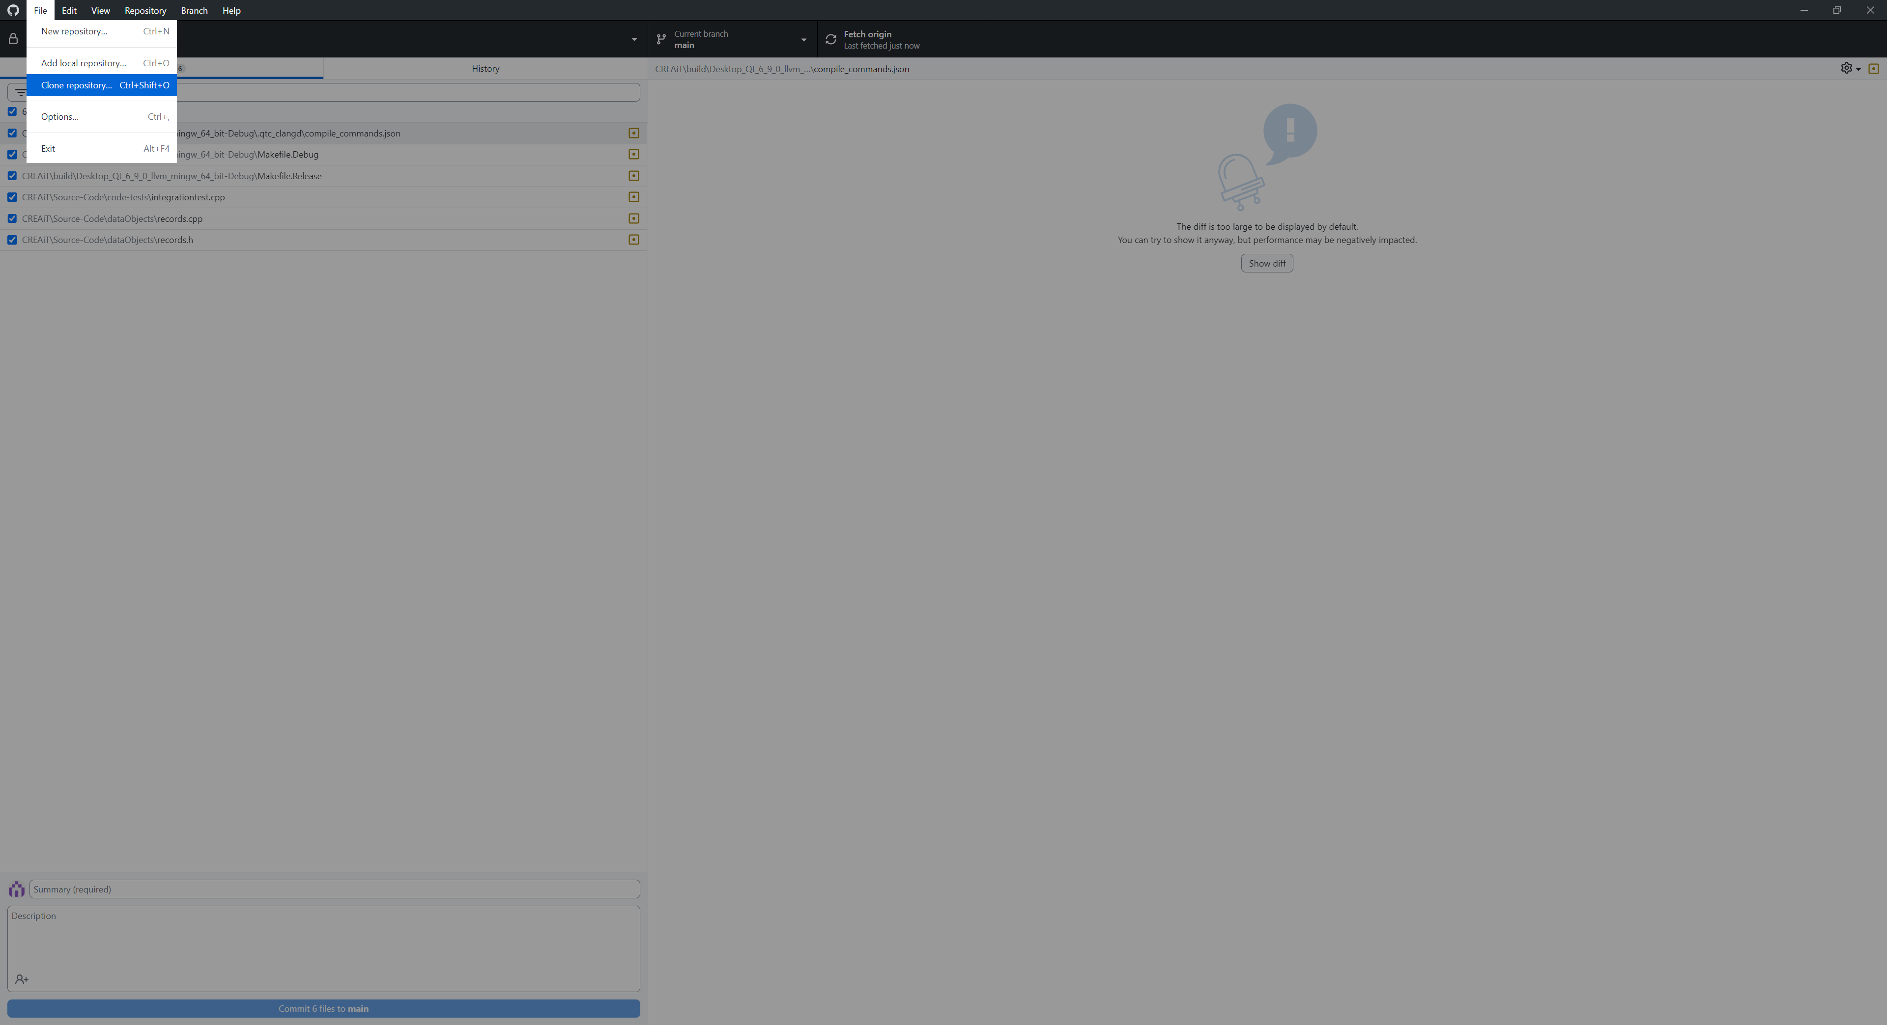

Select your working branch
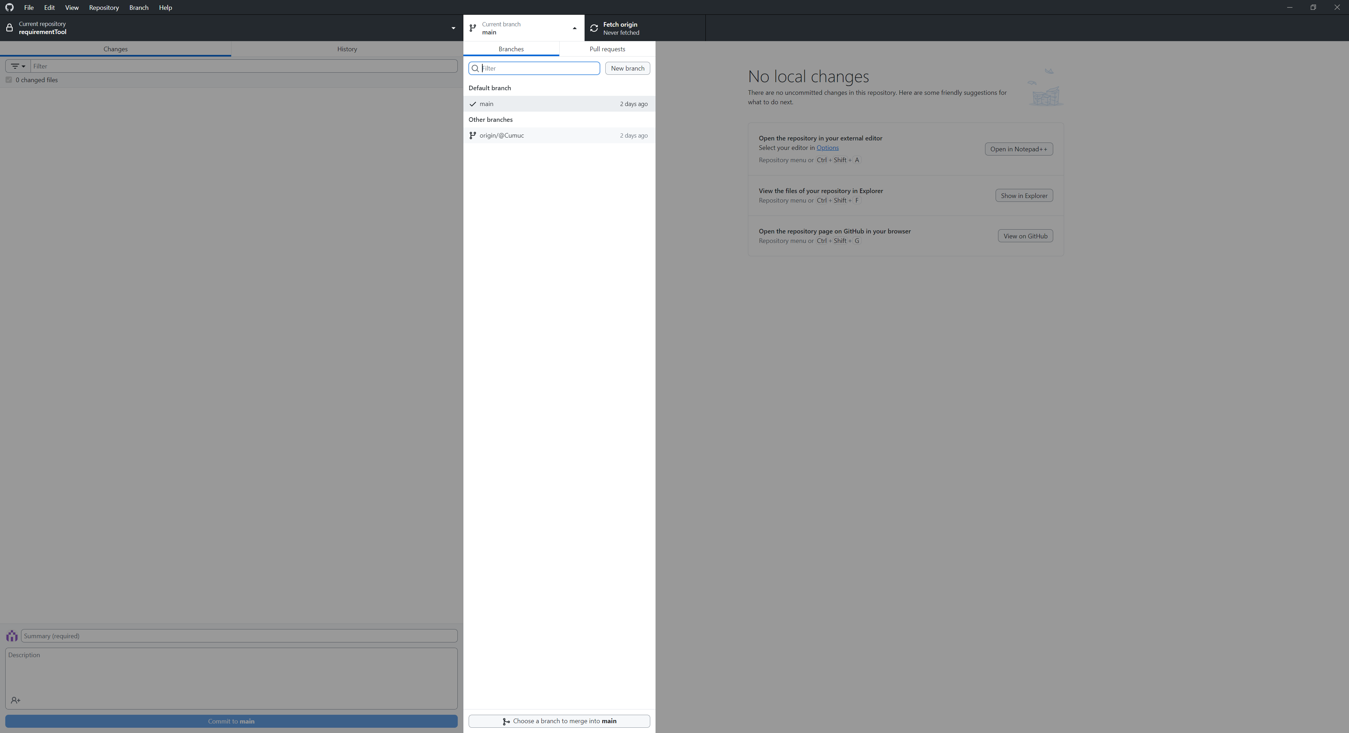

Checking in updates
Make updates to your code.
Use Github to view changes, enter a good title and description for the updates and then commit:
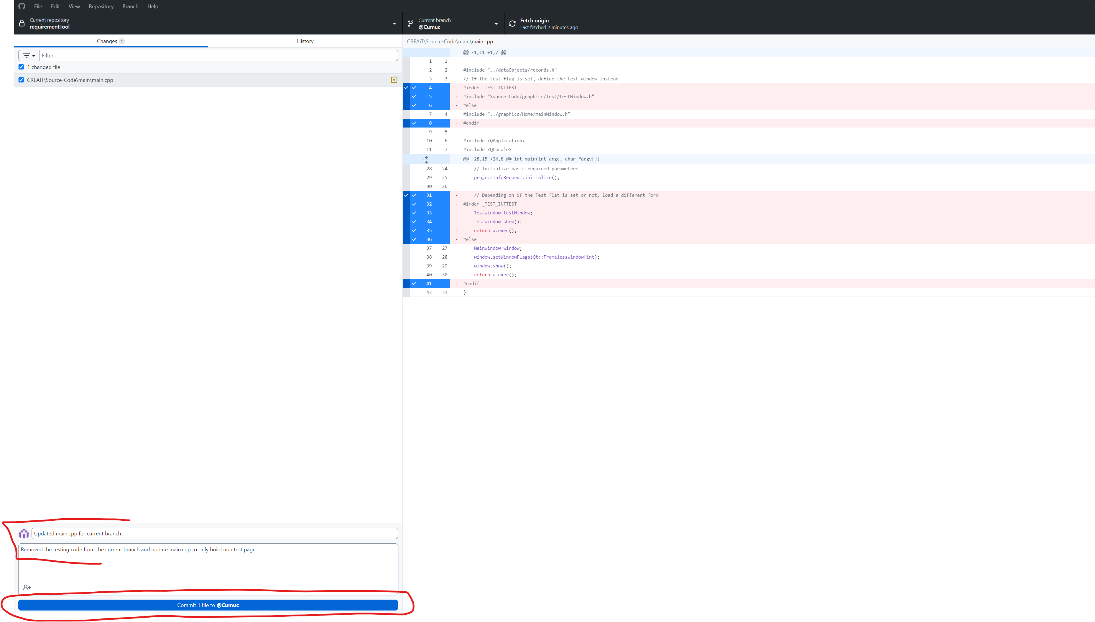
Make sure the correct branch is selected and push to the origin:
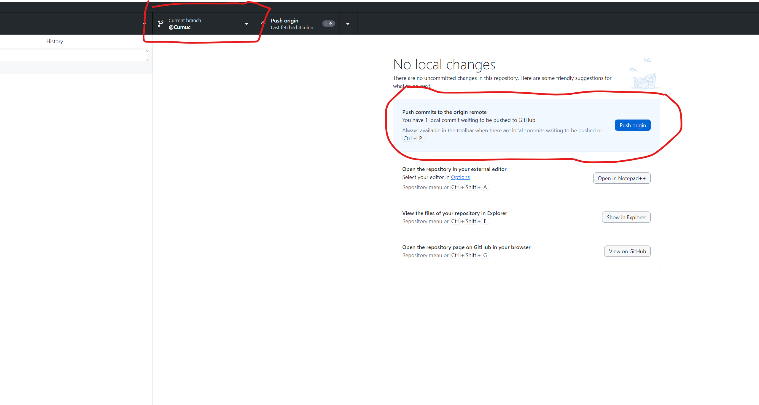

Qt Setup
After getting a copy of the repo, you will need to open the project and configure the kit for the first time:
Upon first loading the Qt project you will need to select the compiler.
- Load the project
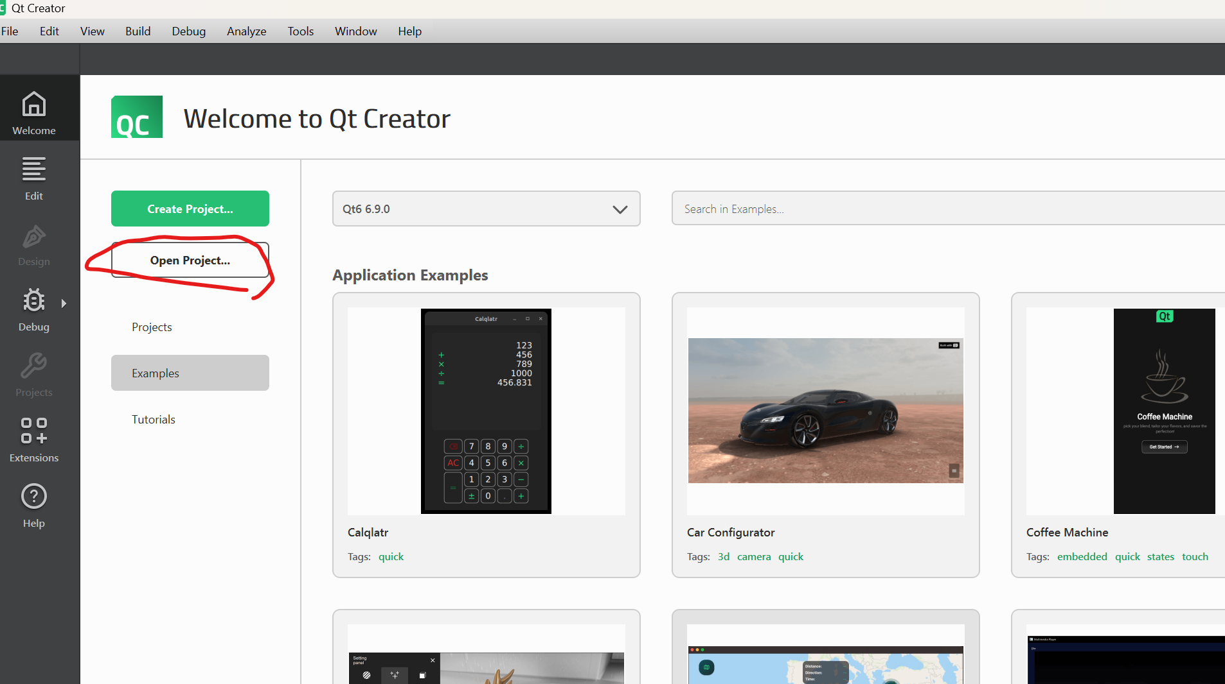
- Select the following toolchain:
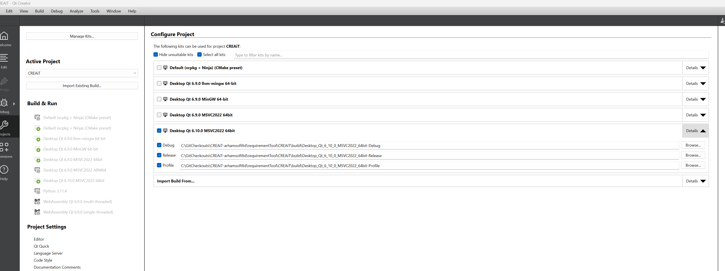
- If you do not see the toolchain, Load it using the Qt Maintenance tool:
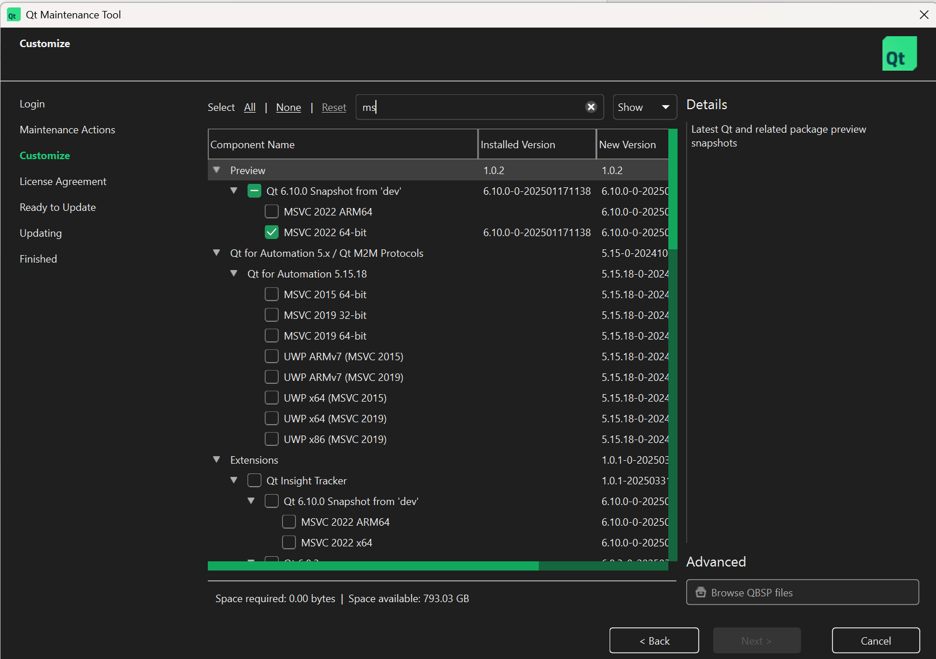

Project Folder Structure
The project is organized according to page in the graphics folders. This is done to keep the codebase maintainable. The main folder is show here:
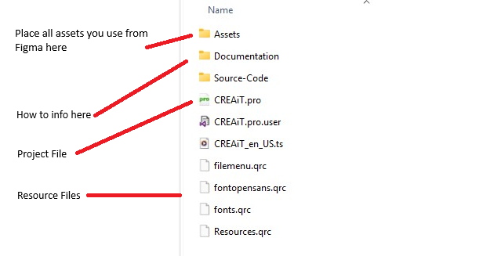

Source Code Structure
The Source-Code folder has the following structure:
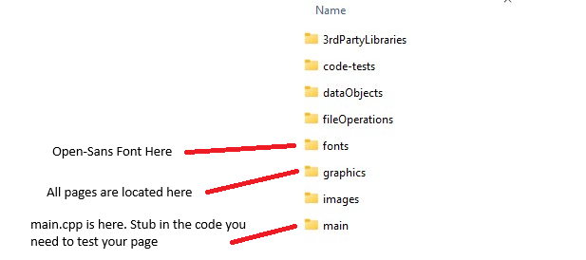

Graphics Directory structure
